**570 Assignment4**

Yifu He 10442277

###Q1:

Step1: after the linear regression (x and y represent xom and cvx), we can get the parameter of sigma and c.

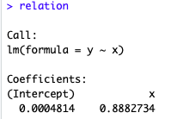

We can also get the summary of the linear regression,

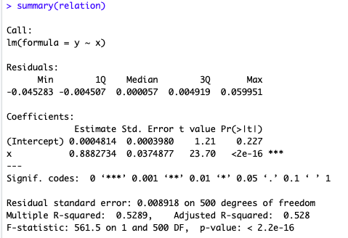

p-value of each parameter is acceptable.

We can draw the plot of the regression.

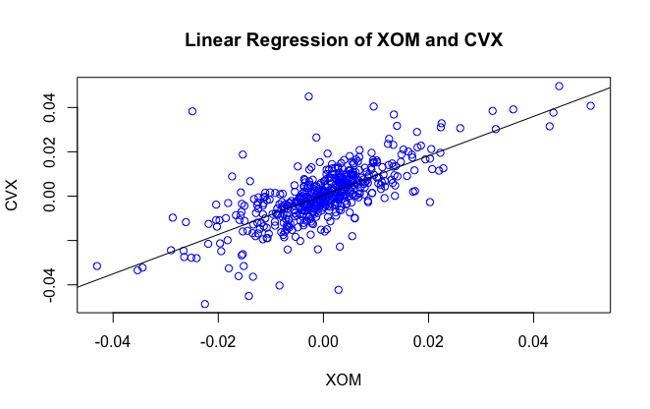

Step2:

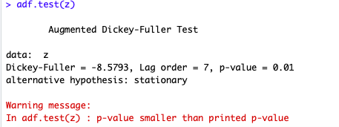

The p-value of is smaller than 0.01, so we reject the null hypothesis and accept the alternative hypothesis that its stationary.

Step3:

Draw a plot of the residentials and the cross point of delta and minus delta.

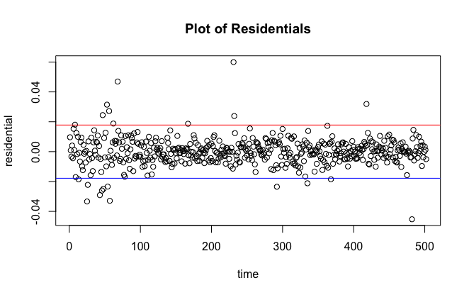

This is the table of transaction signals:

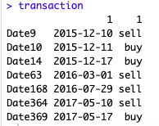

##Question2

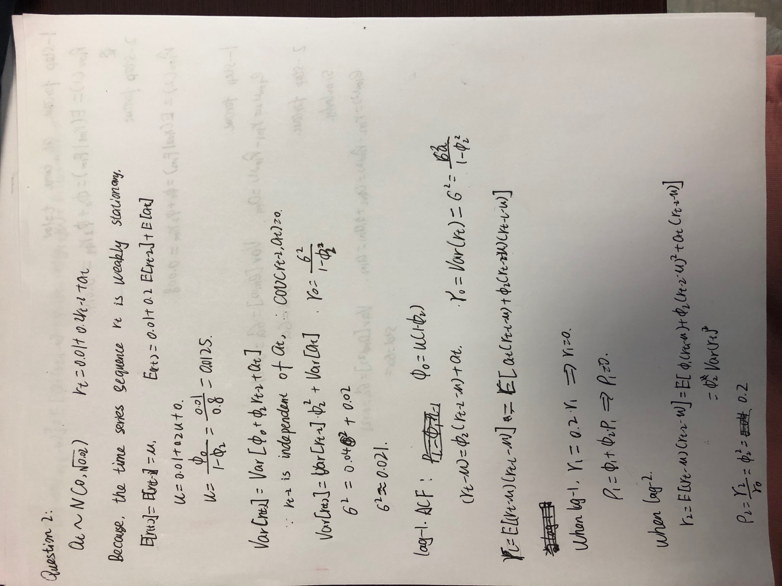

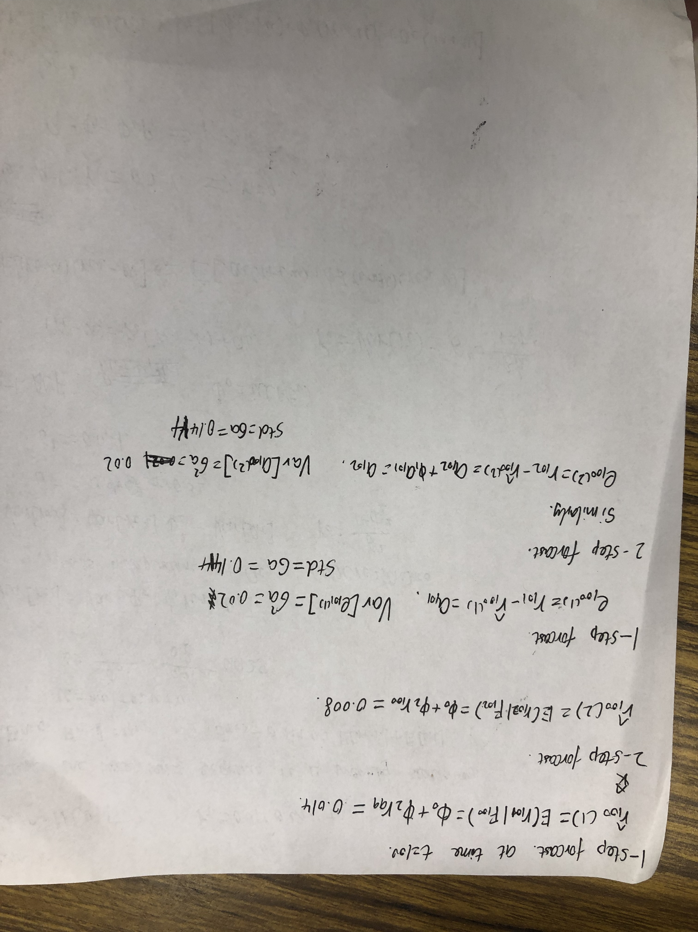

Code:

#homework4 Yifu He 10442277

## invoke the package I will use

library(tseries)

#Question 1

##read the data into R

getwd()

setwd("/Users/yifuhe/Desktop")

cvx_ori <-read.csv("CVX.csv")

xom_ori <-read.csv("XOM.csv")

date<- unlist(cvx_ori[1])

cvx <-unlist(cvx_ori[5])

xom <-unlist(xom_ori[5])

y <-diff(log(cvx))

x <-diff(log(xom))

z<-c(NA)

##1.1

relation <-lm(y~x)

constant<-relation$coefficients[1]

sigma <- relation$coefficients[2]

summary(relation)

#png(file = "linearregression of XOM and CVX.png")

plot(x,y,col = "blue",main = "Linear Regression of XOM and CVX",xlab="XOM",ylab="CVX")

abline(lm(y~x),cex = 1.3,pch = 16)

##1.2

z<-relation$residuals

adf.test(z)

##1.3

stdz<-sd(z)

delta <-2*stdz

plot(z,ylab="residential",xlab="time",main="Plot of Residentials")

abline(h=-delta,col="blue")

abline(h=delta,col="red")

transaction <-data.frame(row.names=c("date","signals"))

for(i in 1:length(z)){

if(abs(z[i]-delta)<=0.001){

temp <- data.frame(date[i+1],"sell")

names(temp)<-data.frame("date","signals")

transaction <-rbind(transaction,temp)

}

if(abs(z[i]+delta)<=0.001){

temp <- data.frame(date[i+1],"buy")

names(temp)<-data.frame("date","signals")

transaction <-rbind(transaction,temp)

}

}

transaction